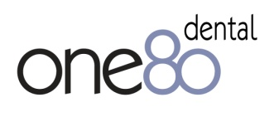

**What do Dental Hygiene Therapists need to know about dental implants?**

**Evening course**

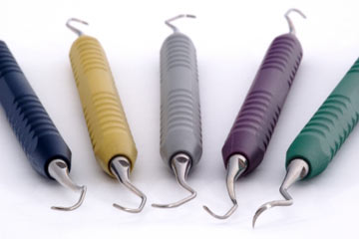

**one80 dental are repeating this popular introductory evening course followed by a full day hands-on training session.**

**Who should attend?**

‘Very informative and enjoyable’ KB

‘Really useful’ JG

‘Great interactive presentation and nice cheese platter’ DK

**Dental Hygiene Therapists**

* **2 Hours verifiable cpd**
* **Supports compliance with regulatory guidelines**
* **Exclusive discounted offers for delegates**

**Date: Wednesday 26 November 2014, 6.30 – 8.30pm**

**Venue: one80 dental, 180 Baslow Road, Sheffield S17 4DS**

**Cost: £25.00**

**The course will be delivered by:**

**Nigel Rosenbaum Specialist in Prosthodontics, Clinical Teacher in Implant Dentistry CCDH**

**Topics will include hygiene friendly restorations and what to do when it gets nasty**

**Refreshments will be provided**

**To book your place, call Jane Davidson on 0114 350 3180 or email** [**jane@one80dental.co.uk**](mailto:jane@one80dental.co.uk)

**We look forward to welcoming you to one80dental**